# CS-600-A Homework 6

Zijing Huang 10414952

**R-10.6 Give an example set of 8 characters and their associated frequencies so that the Huffman tree for this set is a complete binary tree.** Suppose each character has the same frequency, the Huffman tree for this set will be a complete binary tree. For example, I construct a Huffman tree with a set of characters with the frequency of 2:

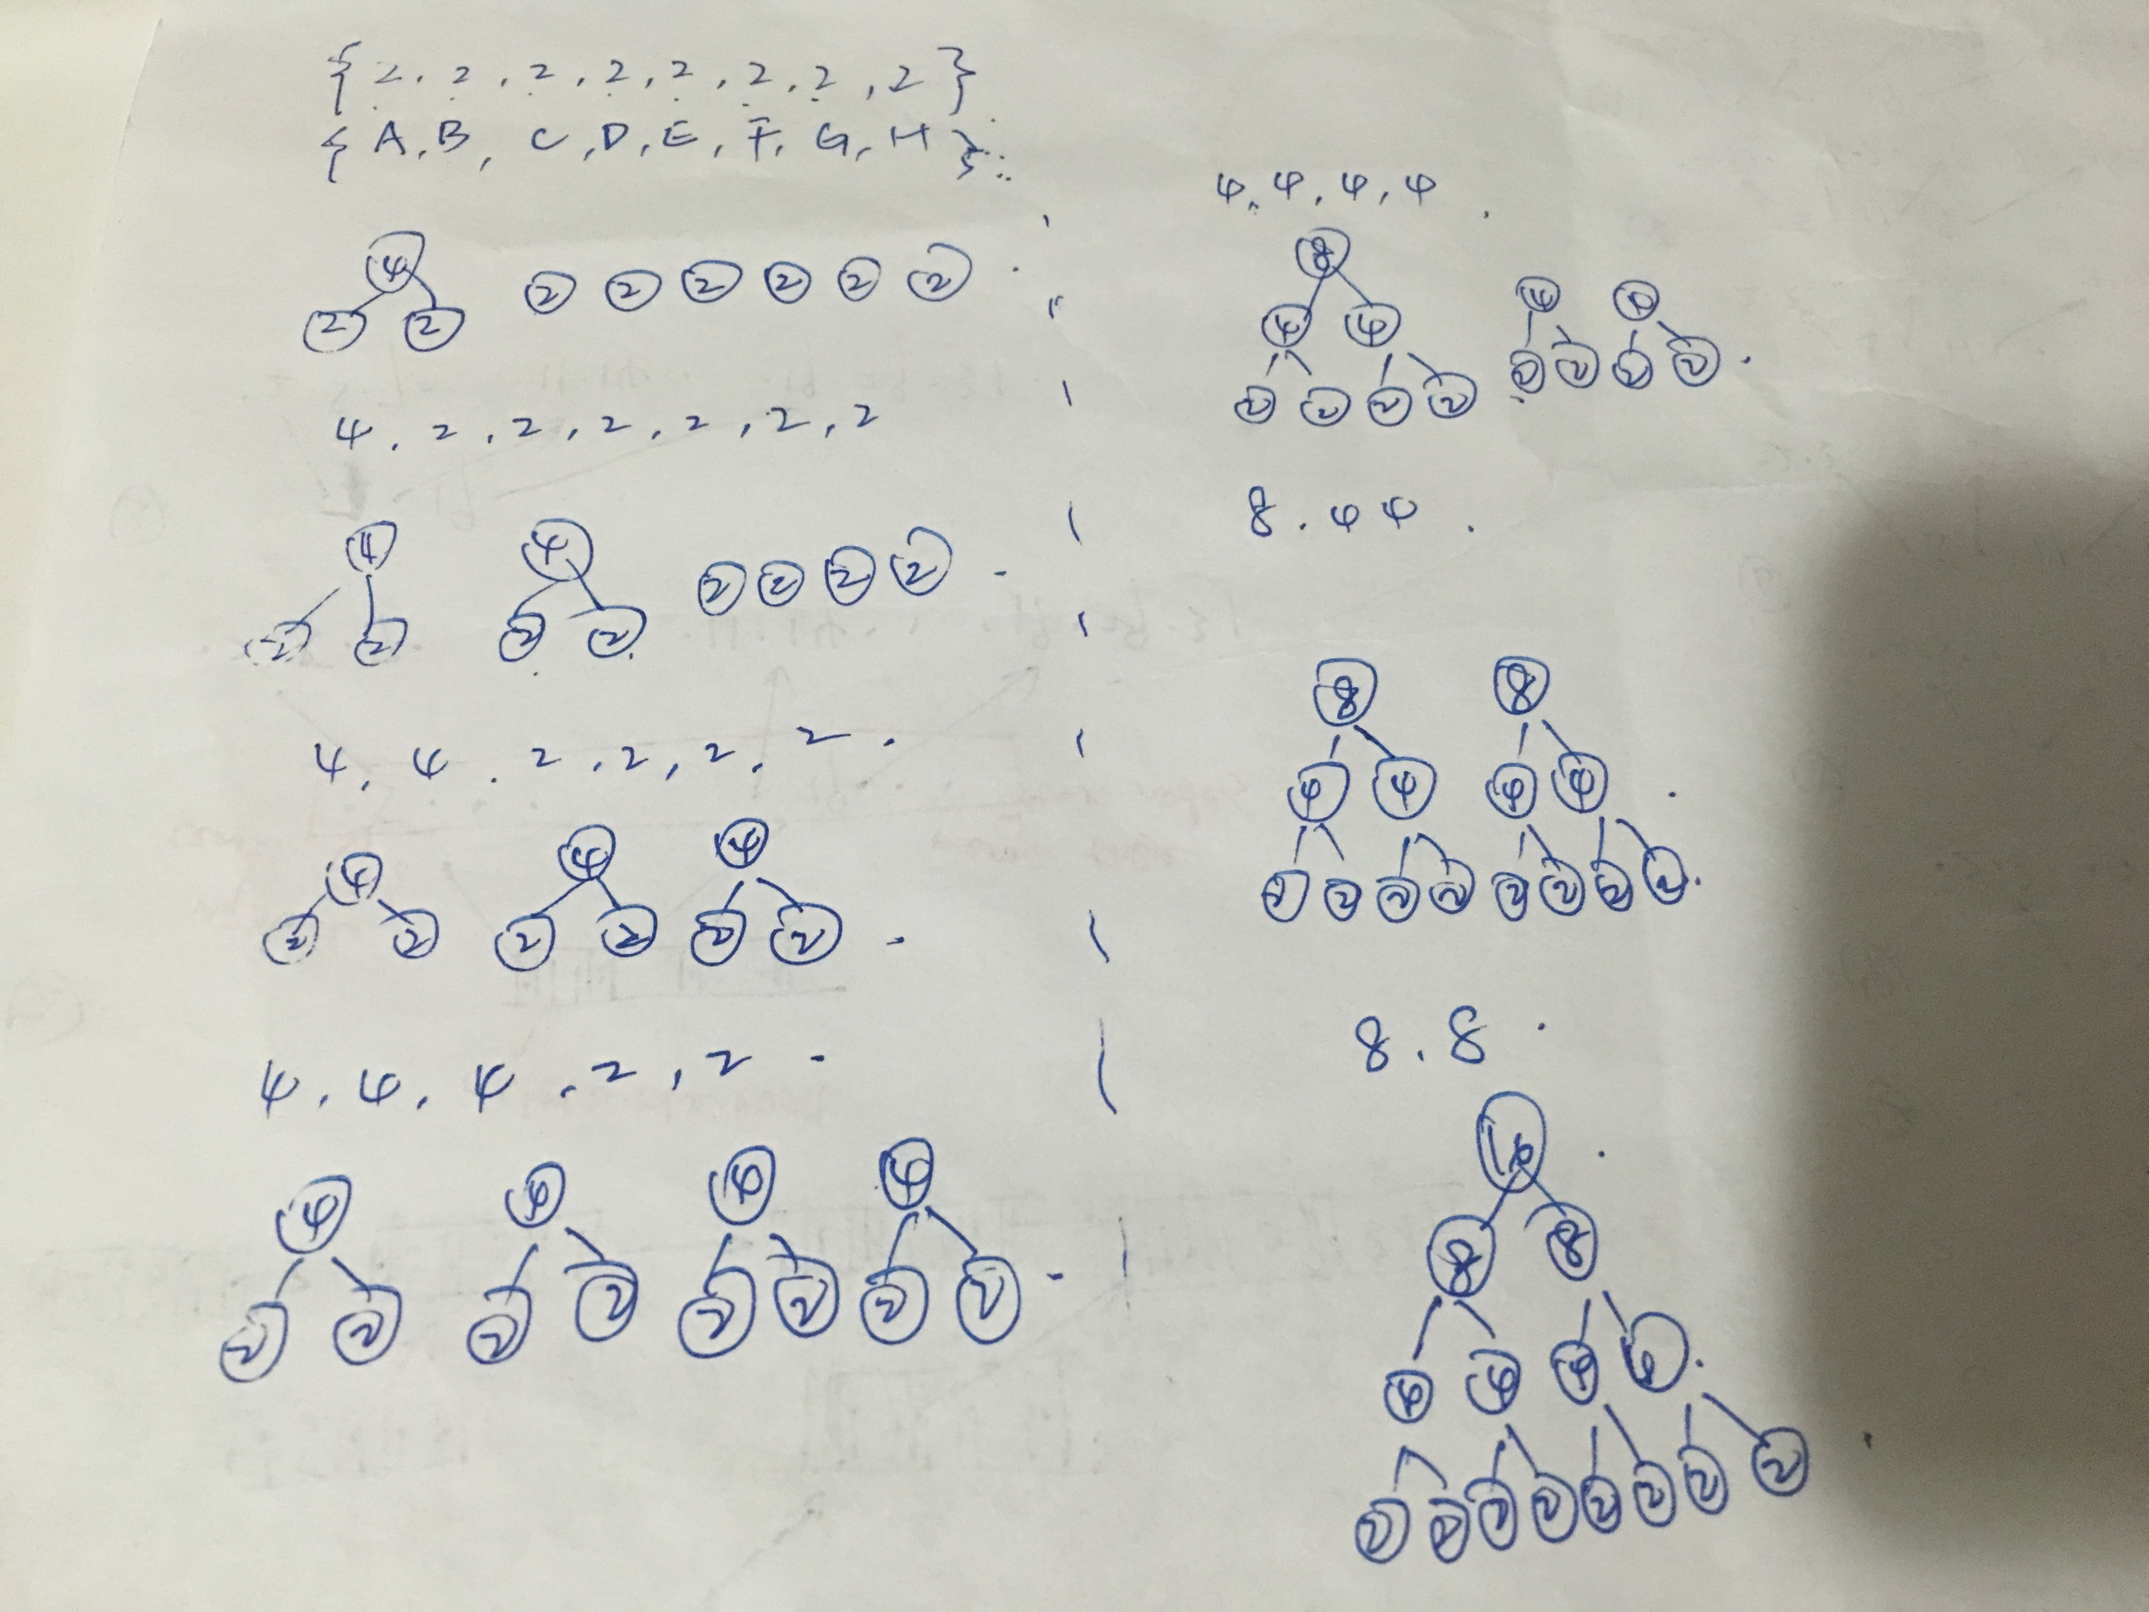

**C-10.5 Describe an efficient greedy algorithm for making change for a specified value using a minimum number of coins, assuming there are four denominations of coins (called quarters, dimes, nickels, and pennies), with values 25, 10, 5, and 1, respectively. Argue why your algorithm is correct.**

Every time we pay with as many quarters as possible. And then for the rest of the price, we pay with as many dimes as possible, and then nickels, and then pennies.

Our algorithm is correct because we always get the best choice and eventually reach the answer. For example, if our target value is 25, we have 4 choices: 1.one quarters 2. two dimes and one nickels 3. five nickels 4. Twenty-five pennies. All of the choices can reach our task, but the first one is the best because it has the minimum coins.

**A-10.1 In the *art gallery guarding* problem we are given a line L that represents a long hallway in an art gallery. We are also given a set X = {x0,x1,...,xn−1} of real numbers that specify the positions of paintings in this hallway. Suppose that a single guard can protect all the paintings within distance at most 1 of his or her position (on both sides). Design an algorithm for finding a placement of guards that uses the minimum number of guards to guard all the paintings with positions in X.**

Firstly, sort the position and let X0 <= X1 <= X2 … <= Xn-1. Scan starting at the leftmost painting and move to the right. Suppose the initial position of the rightmost guard is -∞ . if the current painting is unprotected by the rightmost guard, then place a guard to the right of Xi. Otherwise, move to the next painting.

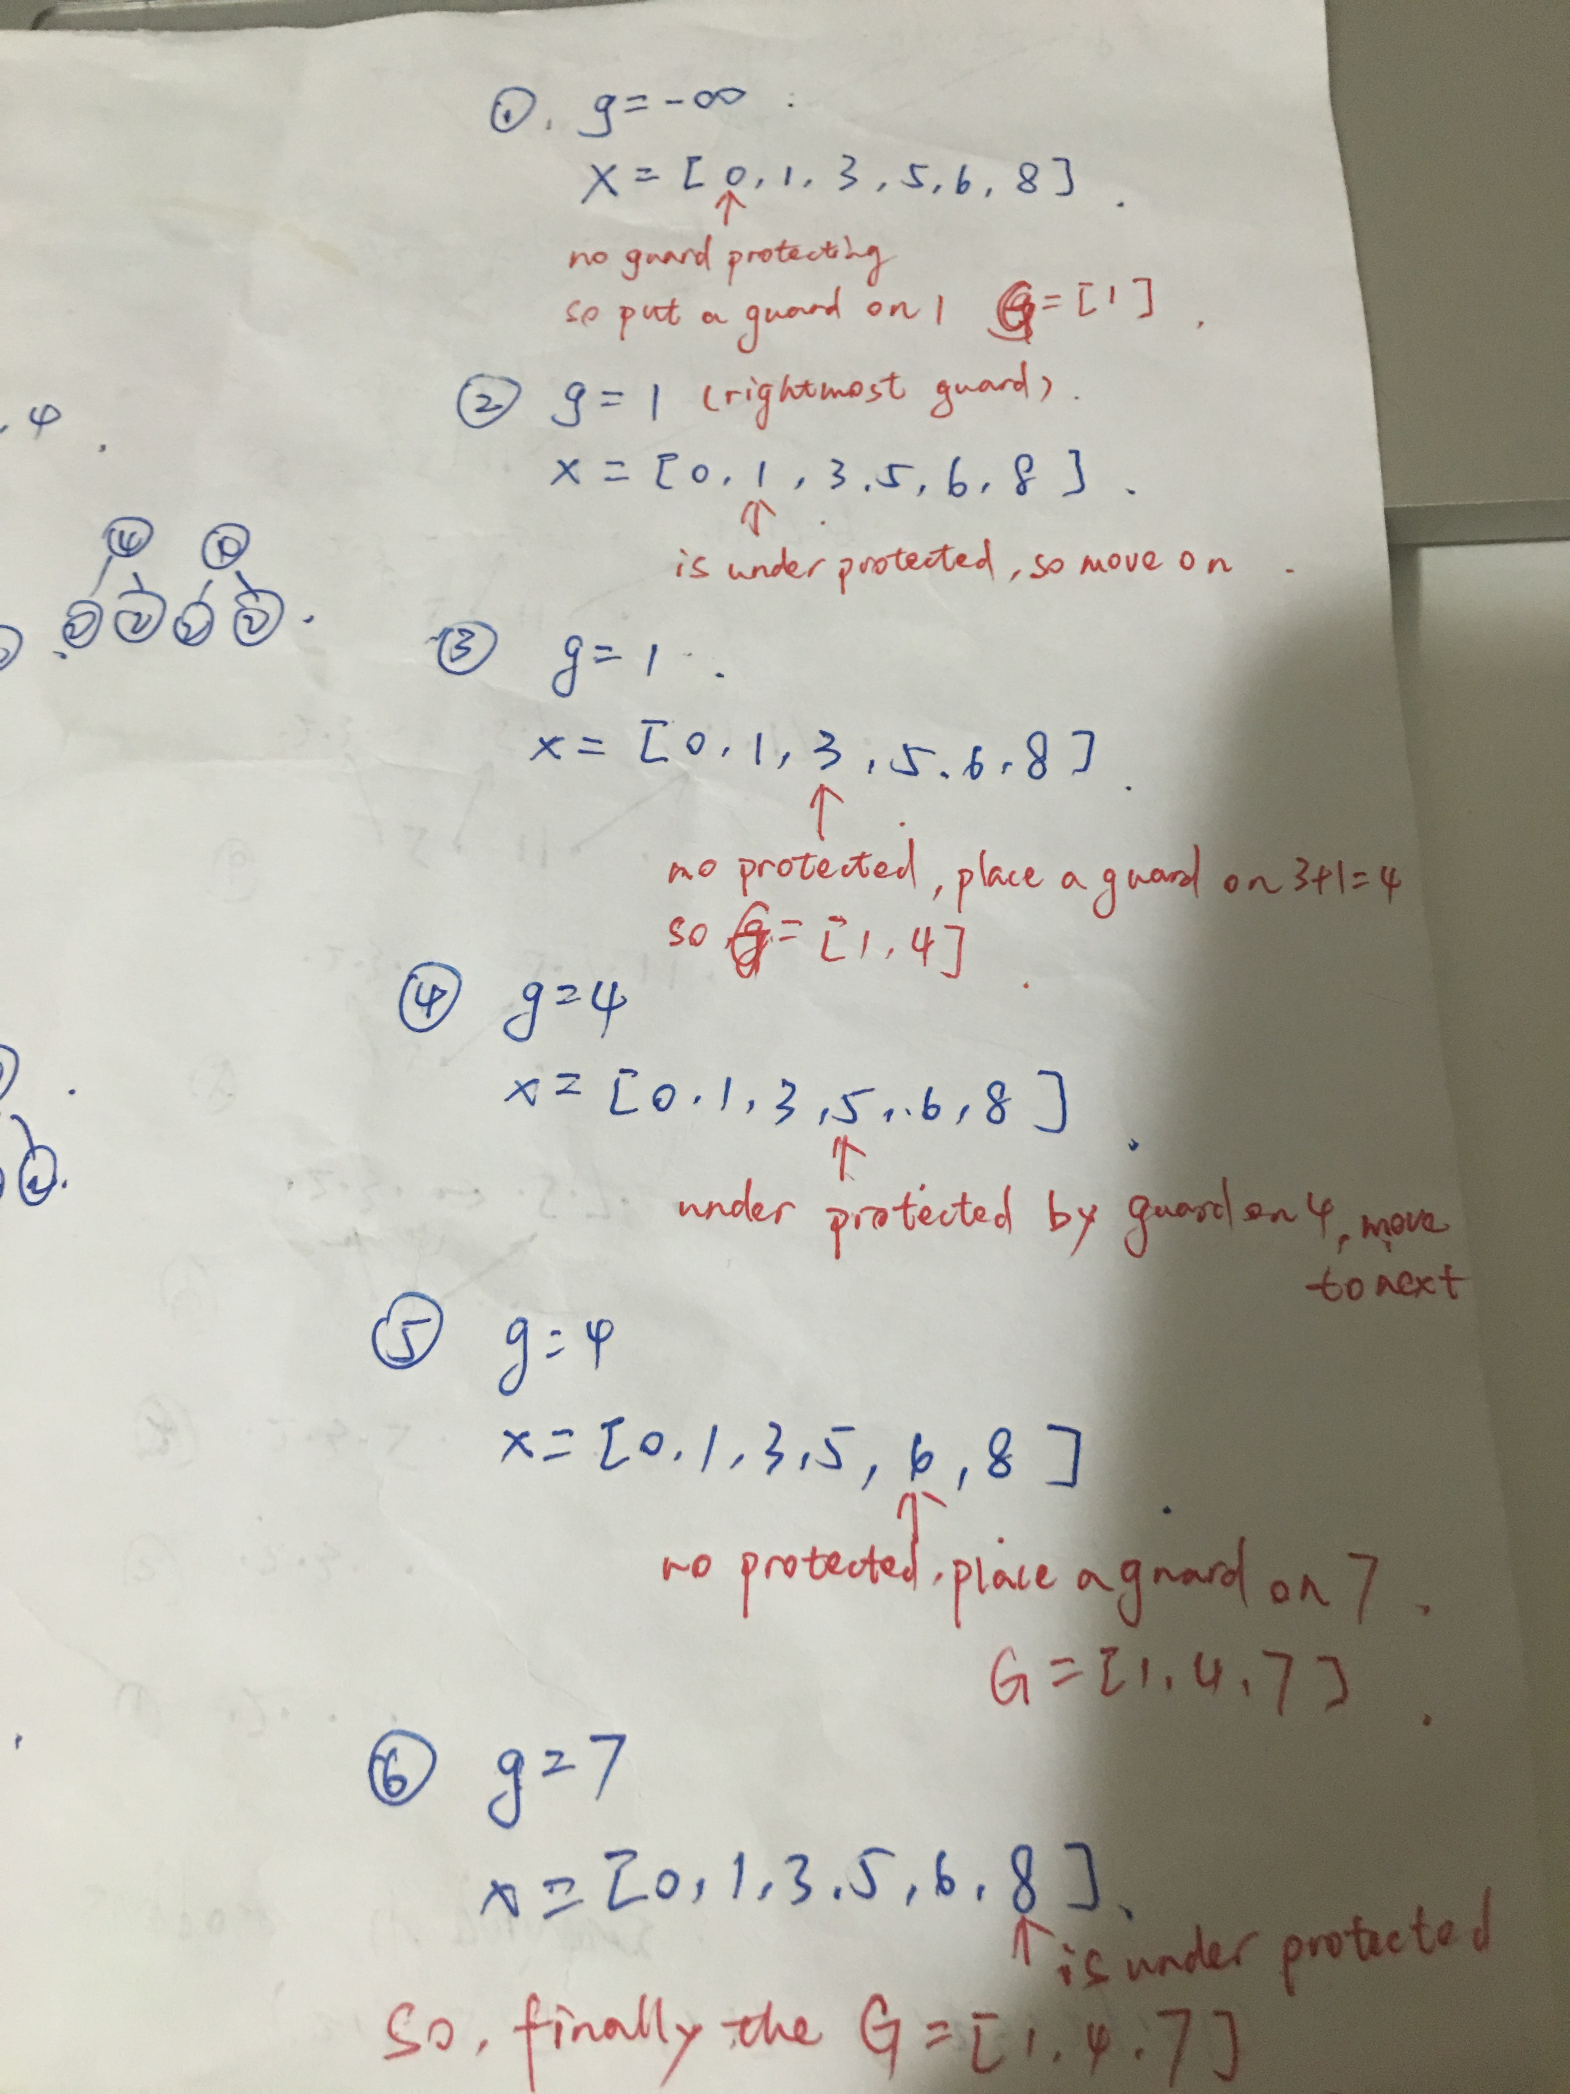

**R-11.1 Characterize each of the following recurrence equations using the master theorem (assuming that T (n) = c for n < d, for constants c > 0 and d ≥ 1).**

1. **T(n)=2T(n/2)+logn**

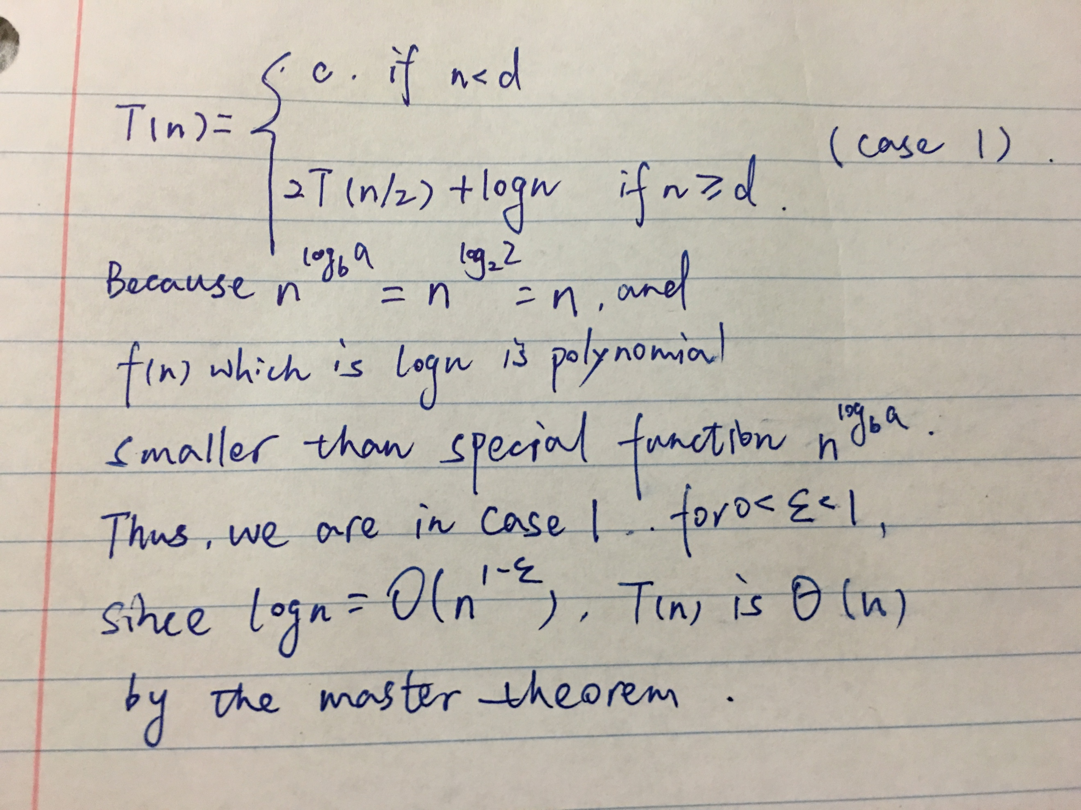

1. **T(n) = 8T(n/2) + n2**

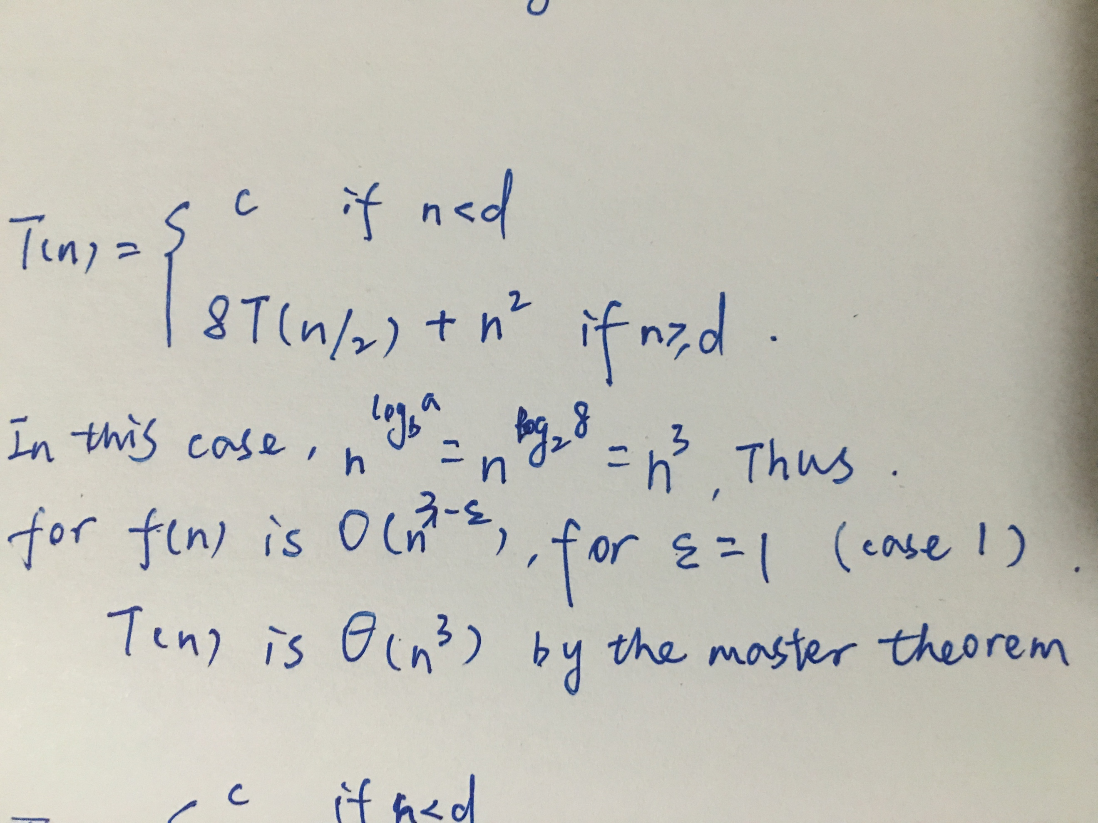

1. **T(n)=16T(n/2)+(nlogn)4**

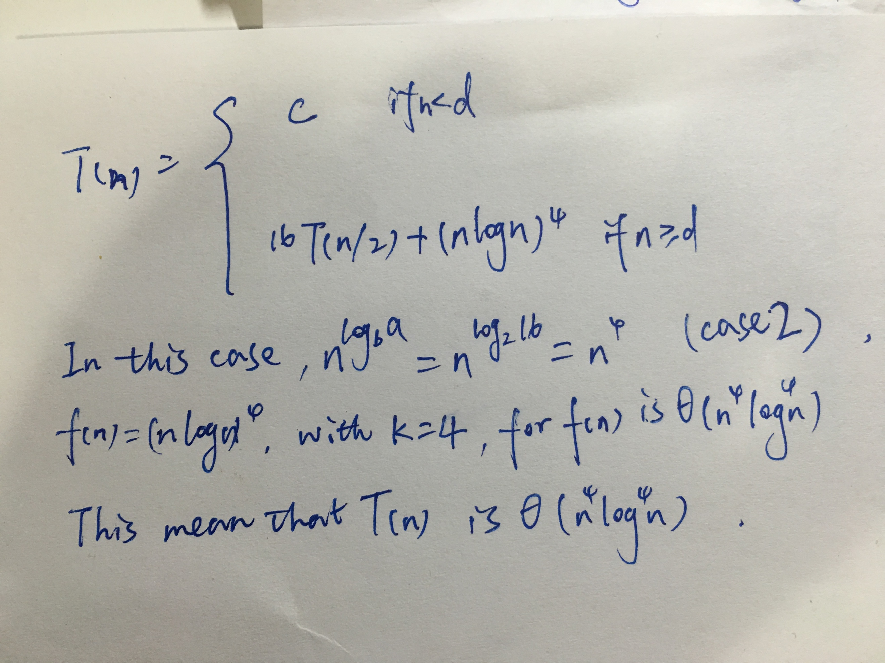

1. **T(n) = 7T(n/3) + n**

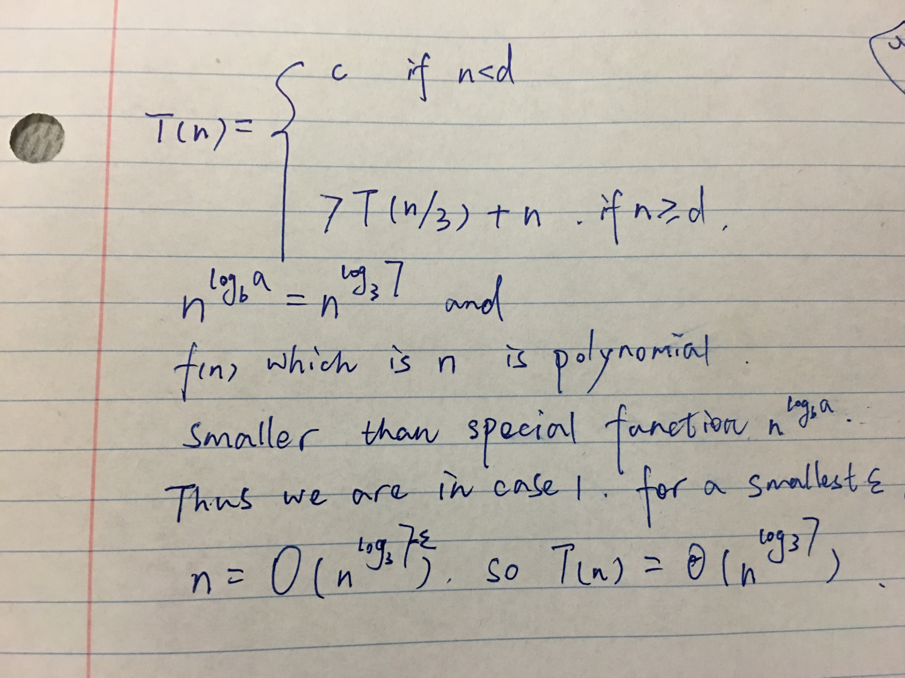

**e. T(n)=9T(n/3)+n3logn**

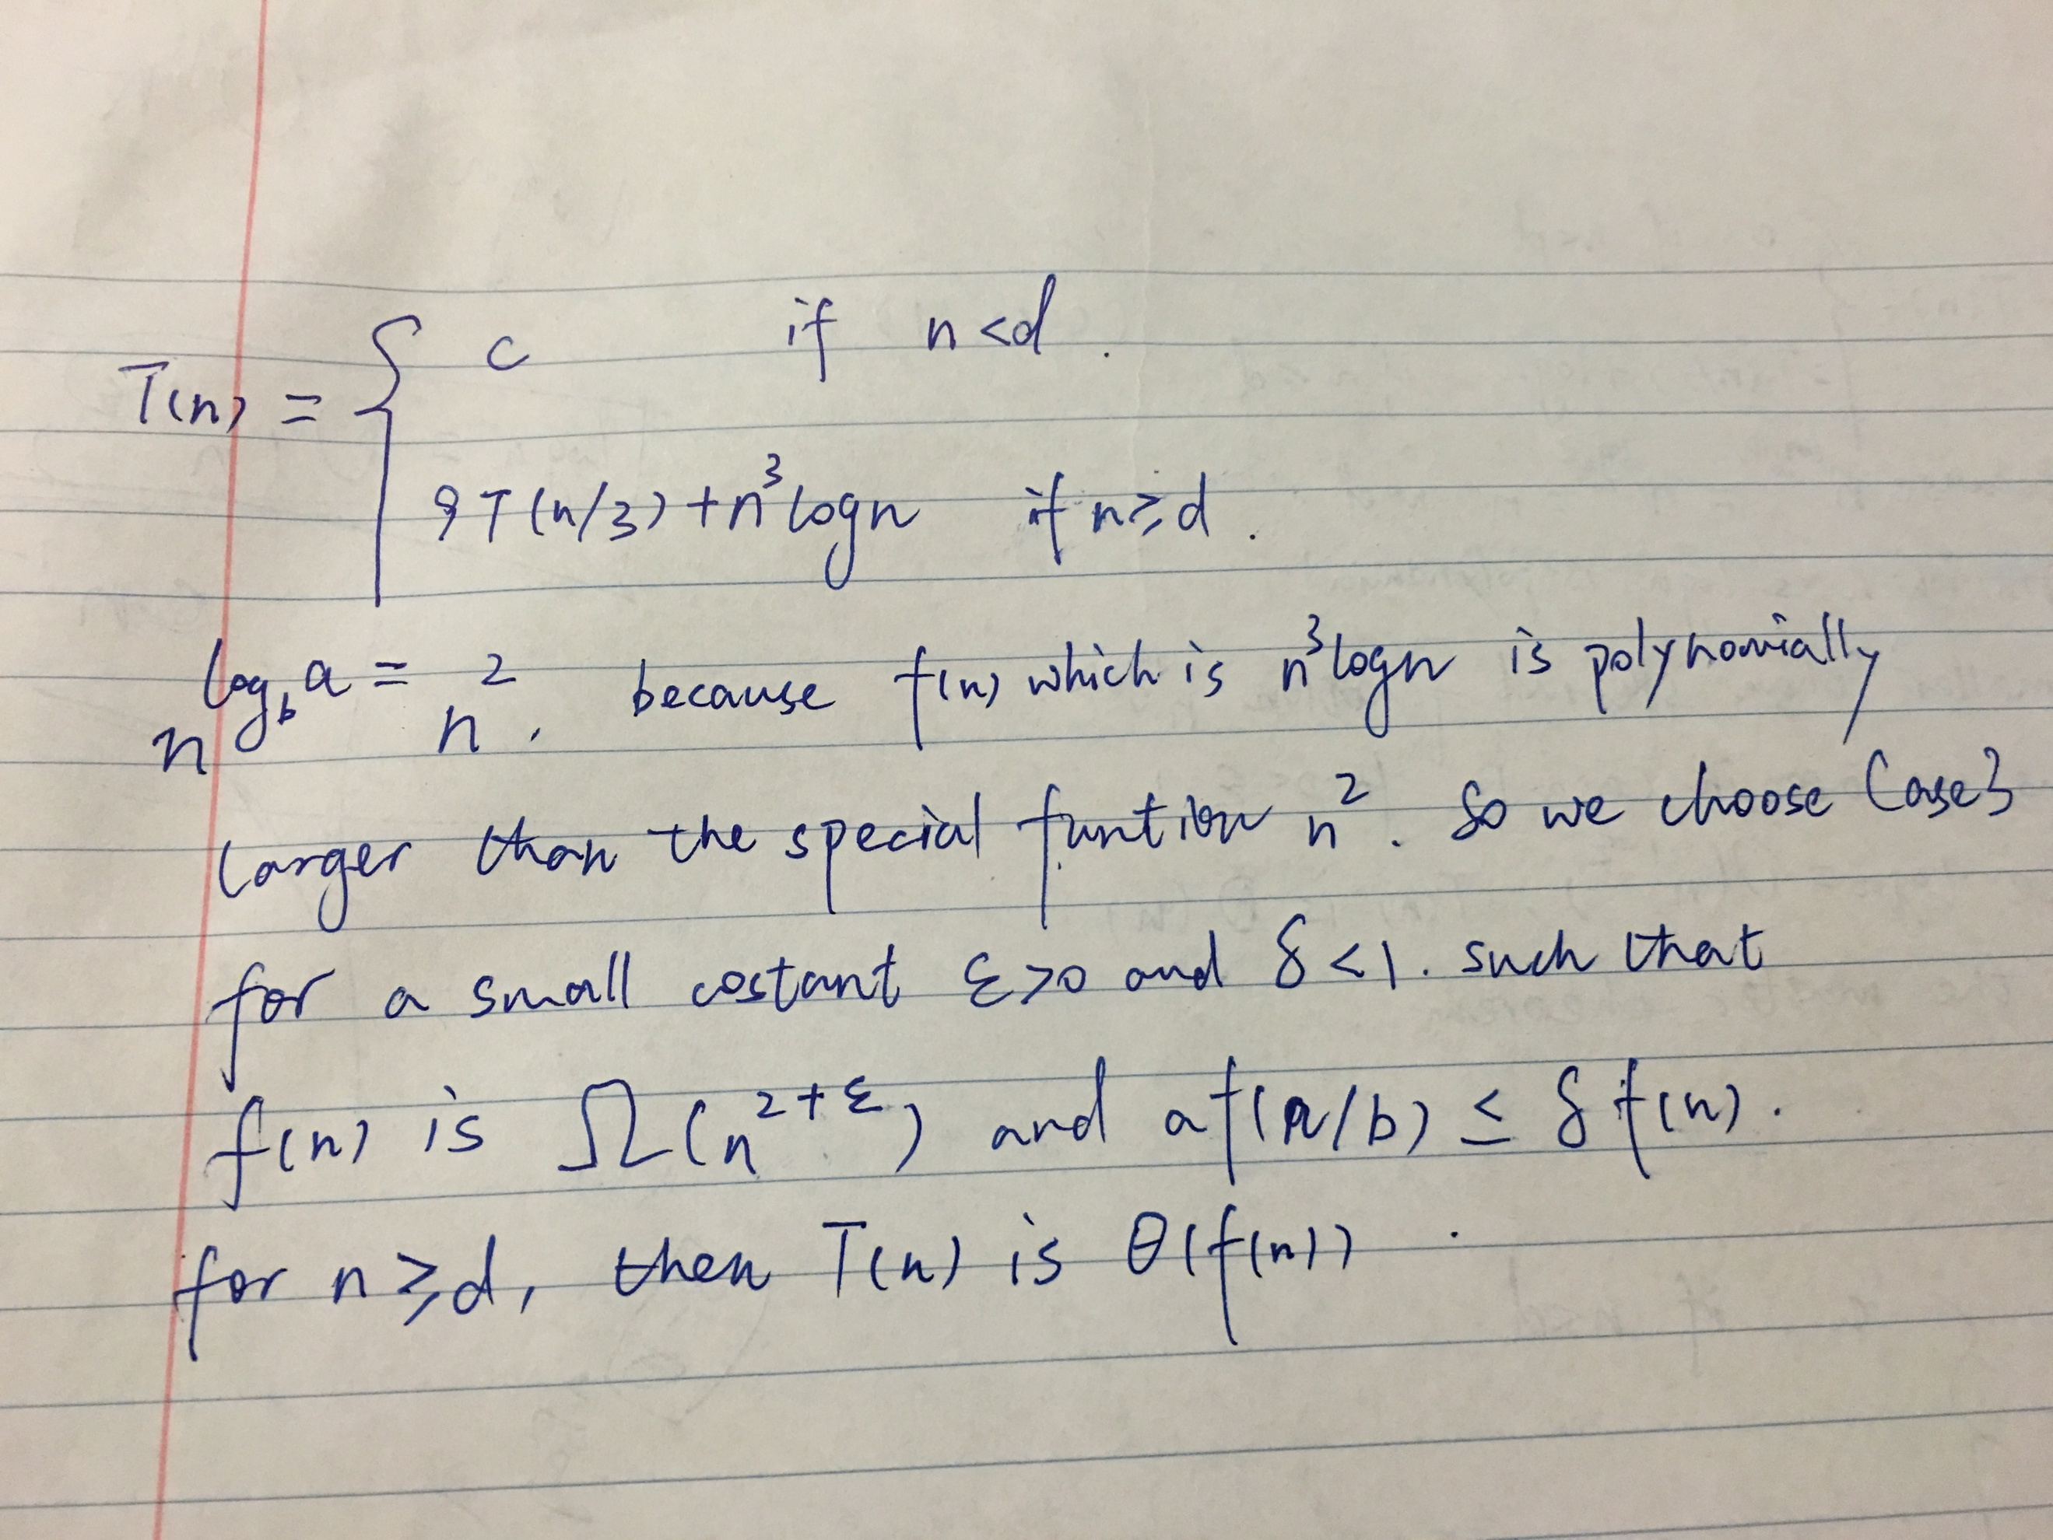

**C-11.3 There is a sorting algorithm, “Stooge-sort,” which is named after the comedy team, “The Three Stooges.” if the input size, n, is 1 or 2, then the algorithm sorts the input immediately. Otherwise, it recursively sorts the first 2n/3 elements, then the last 2n/3 elements, and then the first 2n/3 elements again. The details are shown in Algorithm 11.5. Show that Stooge-sort is correct and characterize the running time, T (n), for Stooge-sort, using a recurrence equation, and use the master theorem to determine an asymptotic bound for T (n).**

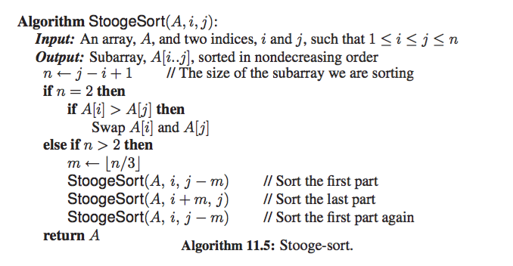

Firstly, if n=2 or n=1, the Stooge-sort is correct because it is sorted immediately. And then for the n>2, suppose T(n) is correct, we use the same algorithm on T(n+1). It recursively breaks T(n+1) to 3 parts of size 2(n+1)/3. Because T(n) is correct, so it is correct for the size less than n as well.

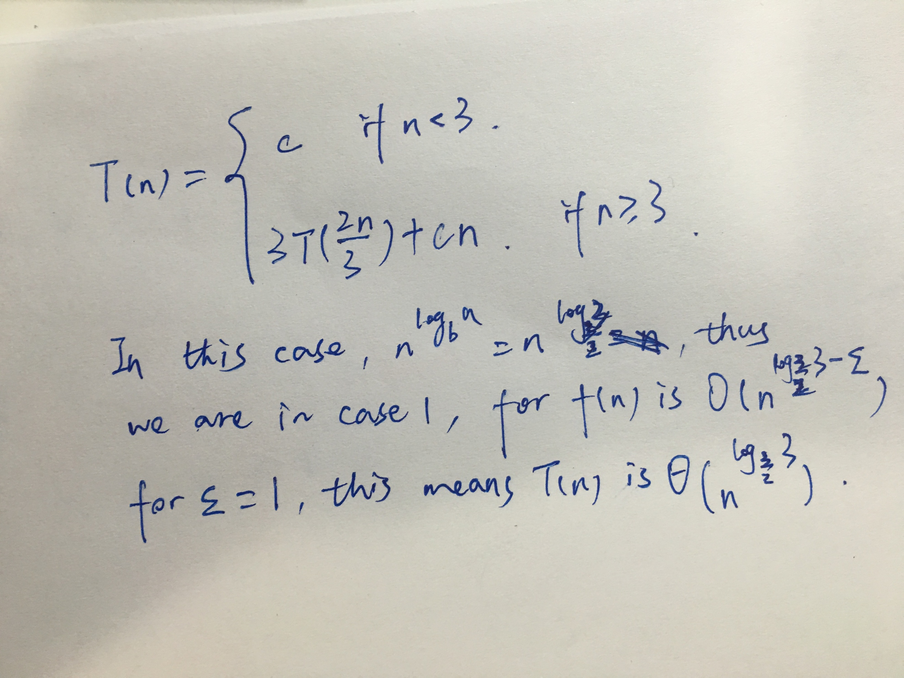

**A-11.1 A very common problem in computer graphics is to approximate a complex shape with a *bounding box*. For a set, S, of n points in 2-dimensional space, the idea is to find the smallest rectangle, R, with sides parallel to the coordinate axes that contains all the points in S. Once S is approximated by such a bounding box, we can often speed up lots of computations that involve S. For example, if R is completely obscured some object in the foreground, then we don’t need to render any of S. Likewise, if we shoot a virtual ray and it completely misses R, then it is guarantee to completely miss S. So doing comparisons with R instead of S can often save time. But this savings is wasted if we spend a lot of time constructing R; hence, it would be ideal to have a fast way of computing a bounding box, R, for a set, S, of n points in the plane. Note that the construction of R can be reduced to two instances of the problem of simultaneously finding the minimum and the maximum in a set of n numbers; namely, we need only do this for the x- coordinates in S and then for the y-coordinates in S. Therefore, design a divide- and-conquer algorithm for finding both the minimum and the maximum element of n numbers using no more than 3n/2 comparisons.**

We group up the numbers into n/2 groups and each group has 2 elements. And then we compute the maximum and minimum of each group. Group up the maximum number of each group into a Max Array and minimum number of each group to a Min Array. And then find the max number in the Max Array and min number in Min Array. This traverse takes n/2 comparisons each.

**R-12.9 Sally is hosting an Internet auction to sell n widgets. She receives m bids, each of the form “I want ki widgets for di dollars,” for i = 1, 2, . . . , m. Characterize her optimization problem as a knapsack problem. Under what conditions is this a 0-1 versus fractional problem?**

If the bidders accept partial lots of Ki widgets, then it is a fractional knapsack problem. Otherwise, it is a 0-1 problem.

**A-12.3 An American spy is deep under cover in the hostile country of Phonemia. In order not to waste scarce resources, any time he wants to send a message back home, he removes all the punctuation from his message and converts all the letters to uppercase. So, for example, to send the message,**

**“Abort the plan! Meet at the Dark Cabin.”**

**he would transmit**

**ABORTTHEPLANMEETATTHEDARKCABIN**

**Given such a string, S, of n uppercase letters, describe an efficient way of breaking it into a sequence of valid English words. You may assume that you have a function, valid(s), which can take a character string, s, and return true if and only if s is a valid English word. What is the running time of your algorithm, assuming each call to the function, valid, runs in O(1) time?**

We maintain a dp array dp[i]. Let dp[i] = true when there is a j, such that j < i, dp[j] = true and valid(string S[j:i])==true. At the beginning, dp[0]=true. The total running time would be O(n2) because we use O(1) n times to check if dp[i] is true.